Shanghai Goodview Electronic Technology Co., Ltd.
Specification
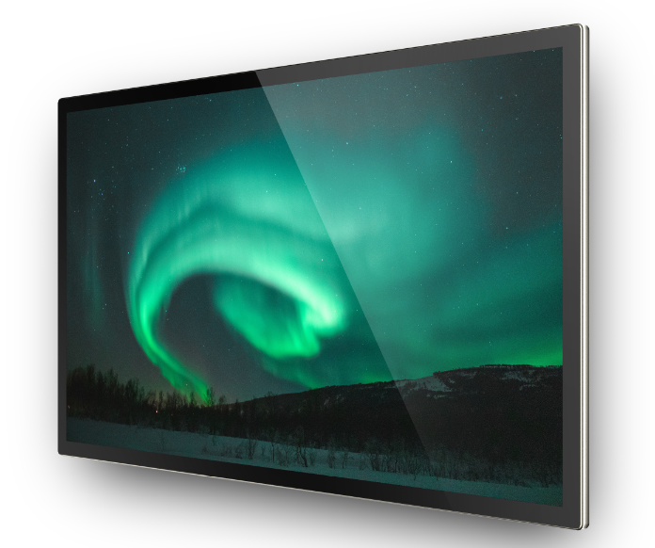
TC55H1

Sign and Date by: ___________ Sign and Date by: ____________

Customer GoodView

Content
Chapter I. Revision History 2
Chapter II. Summary 3
2.1. Statement 3
2.2. Safety instructions 4
Chapter III. Product Parameter 5
3.1. Main Technical Parameters 5
3.2 LCD Panel Technical Parameters 7
3.3. Input Signal 8
3.3.1. HDMI Port 8
3.3.2. VGA Port 9
3.4. Specification Overview 9
3.5. External Interface Portion 10
Chapter IV. Mechanical Portion 11
4.1. Outline drawing 11
Chapter V. Packaging Portion 11
5.1. Packing Size 11
5.2. Packaging Drawings 12
5.3. Nameplate 13
5.4. Labels 13
5.4.1. Nameplate Labels 13
5.4.2. Packaging Labels 14
Chapter VI. Environmental Requirement 14
6.1. Operating Temperature 14
6.2. Storage Temperature 14
Chapter VII. ID Rendering 15
7.1. Six Sides Figure 15
7.2. Front View 15
7.3. Back View 16
7.4. End View 17
7.5. Interface Rear View 17

Chapter I. Revision History
Parts No. | Version | Revision History | Date | Written by | Auditing | Approval
1410077 | V1.0 | First issue | 2019/11/22 | 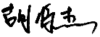 | / | 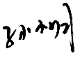

Chapter II. Summary

2.1. Statement
All parts of this product, including accessories and software, all the intellectual property right are owned by Shanghai Goodview Electronic Technology Co., Ltd. (hereinafter refers to "Goodview") or authorizes the relevant subjects xxxx to use. Without the permission of the right subjects, no copying or translation is allowed.
There is no any form of guarantee, position expression or other implication in this manual, if there is any direct or indirect loss of data, loss of profits or termination of business caused by the product information mentioned in this manual, Goodview and its employees are not liable for it. In addition to this, the product specifications and information mentioned in this manual are only for reference and will be updated at any time without further notice. Faults or damages caused by the following factors are not covered by free warranty:
- Damage caused by natural disasters (floods, fires, earthquakes, lightning strikes, typhoons, etc.), force majeure or inadvertent use of man-made operations.
- Self-assemble, repair, or send the product to a maintenance shop not authorized or certified by Goodview for inspection and repair.
- Damages and faults caused by users who may or request a third party to modify, repair, alter specifications and install, add and expand parts that are not sold, authorized or approved by our company without authorization.
- Usage problems and faults caused by improper installation and setting of software by users themselves.
- Problems and malfunctions caused by computer viruses.
- Warranty identification label of our company is torn or unrecognizable.
- Other problems and faults caused by abnormal use.
The product names mentioned in the user's manual are only for identification, and these names may belong to registered trademarks or copyrights of other companies.

Goodview reserves the right to change any or all specifications without notice. The information contained in this document is subject to change without notice.

For the latest upgrade information of product specifications, please call to Shanghai Goodview Electronic Technology Co., Ltd.

2.2. Safety instructions
Safety of Electrical
- In order to avoid serious damage caused by possible electric shock, please remove the power cord of the equipment temporarily from the power socket before moving the equipment
- When you want to add or remove the hardware device in the system, you must connect the data line of the device first and then the power line. If possible, unplug the power cord of the device before installing the hardware device.
- Before you connect or unplug any data lines from the module, make sure that all the power lines have been unplugged beforehand.
- Before using an extension card or an adapter card, we suggest that you seek for professional assistance first. These devices may interfere with the grounding circuit.
- Make sure that the voltage settings of the power supply have been adjusted to the voltage standard values used in the country/region. If you are not sure what the supply voltage value is in your area, please ask the local power company personnel nearby.
- If the power supply is damaged, please do not attempt to repair it by yourself. Please seek the help of professional technical service personnel.
Safety in operation
- Before you install modules and add hardware devices, be sure to read the relevant information provided in this manual in detail.
- Before using the product, make sure that all the data lines and power lines are connected correctly. If you find any defects, please contact Goodview as soon as possible.
- In order to avoid electrical short circuit, make sure that all unused screw, paper clip and other parts are put away, and do not leave them on the module or in the equipment.
- Dust, moisture and drastic temperature changes will affect the life of the motherboard, so please try to avoid placing them in these places.
- Do not place the equipment in a place that is easy to shake.
- If there are any technical problems in the use of this product, please contact the technicians who have been verified or experienced.

Chapter III. Product Parameter

3.1. Main Technical Parameters
NO | Subtype | Name |  | Parameter | Unit | Note
1 |  | Panel |  | 54.64 inches (1387.8mm) LED backlight
2 | Product  Parameter | Product size (mm) |  | 1275(H)×745.8 (V)×56.8(D) | mm
3 |  | Active size (mm) |  | 1208.6（H）×679.4(V） | mm
4 |  | Color |  | Gold and black
5 |  | Weight (Gross) |  | 36.9 | KG
6 |  | Weight (Net) |  | 29.4 | KG
7 |  | Speaker |  | Stereo 2×2W 4Ω | Watt
8 |  | Screen hanging mode |  | Portrait\Landscape
9 |  | OSD Language |  | Chinese\English
10 |  | Play mode |  | Horizontal Vertical Split display Play List
11 |  | Multimedia transmission |  | USB、WAN、LAN
12 |  | Watchdog function |  | Support
13 |  | Smart volume |  | Time-sharing volume
14 |  | Timing function |  | Multi-time timing power on/off, port timing automatic switch
15 |  | Management Software |  | C/S framework: ADPE/Ezposter  B/S framework: GTV Information Distribution System
16 | Core | CPU |  | RK 3288 Quad-core ARM Cortex A17 （Max. 1.8GHz）
17 |  | GPU |  | Quad-core ARMMail-764
18 |  | Memory |  | DDR3 2GB
19 |  | Storage |  | 8GB eMMC
20 |  | Operation System |  | Android 7.1
21 | Touch Panel | Touch Type |  | Capacitive
22 |  | Touch Point |  | 10 point
23 |  | Touch precision |  | 2.5mm±10%
24 |  | Touch resolution |  | 16384 X 9600（MAX）
25 |  | Response time |  | ＜10ms
26 |  | Enter mode |  | Finger、capacitive stylus
27 |  | Smallest touch objects |  | Single: N/A  Multipoint：N/A
28 | Multimedia | Picture | Extension | JPG、JPEG、BMP、PNG, etc | TBD
29 |  | Audio | Extension | MP3 audio format, etc
30 |  | Video | Extension | MPEG1、MPEG2、MPEG4、H.264、WMV、MKV、TS、flv and other mainstream video formats
 |  |  | Encoder/  bit rate | MPEG-1 bitrate<20Mbps  MPEG-2 bitrate<20Mbps  MPEG-4 bitrate<20Mbps  H.264 bitrate<20Mbps  AVC bitrate<20Mbps  VC-1 bitrate<20Mbps  RM bitrate<10Mbps
31 |  | Text | Extension | .txt
32 |  | HTMI 5 |  | Support
33 | Installation | VESA standard |  | 400×200 (Screw type M6×10mm）
34 |  | Hanging mode |  | VESA installation
35 | Accessories |  |  | - Power line×1  - 2.4G Wi-Fi antenna×1  - Remote control×1  - AAA battery×2  - Double male head USB×1
36 | Certification

3.2. LCD Panel Technical Parameters

 |  | Symbol | Parameter |  |  | Unit | Note
 |  |  | Min | Typ | Max
LCD Panel Size |  |  | - | 54.64 | - | inches | Led backlight
Active Screen Size |  |  | 1209.6（H）×680.4(V） |  |  | mm
Pixel Format |  |  | 3840×2160 |  |  | Pixels
Panel Luminance |  |  | 360 | 450 |  | cd/m2
Production Luminance |  |  | 305 | 380 |  | cd/m2
Contrast Ratio |  | CR | 900 | 1300 | -
Color Depth |  |  | 10bit, 1.07 Million colors
Pixel Pitch |  |  | 0.315 mm x 0.315 mm |  |  | mm
Color temperature |  |  | 9000 | 11000 |  | K
Response Time |  | G to G BW | - | 9 | 13 | ms
Backlight Life Time |  |  | - | 30000 | - | Hrs
Viewing Angle | Xaxis,right=0° | R | 89 | - | -
 | x axis, left=180° | L | 89 | - | -
 | y axis, up =90° | U | 89 | - | -
 | yaxis, down=270° | D | 89 | - | -

3.3. Input Signal

3.3.1. HDMI Port
Resolution | Refresh
1024x768 | @60Hz/50Hz
1600x900 | @60Hz/50Hz
1280x800 | @60Hz/50Hz
1280x720 | @60Hz/50Hz
1280x1024 | @60Hz/50Hz
1360x768 | @60Hz/50Hz
1366x768 | @60Hz/50Hz
1440x900 | @60Hz/75Hz
1680x1050 | @60Hz/50Hz
1920x1080 | @60Hz/50Hz

3.3.2. VGA Port
Resolution | Refresh
1024x768 | @60Hz/50Hz
1600x900 | @60Hz/50Hz
1280x800 | @60Hz/50Hz
1280x720 | @60Hz/50Hz
1280x1024 | @60Hz/50Hz
1360x768 | @60Hz/50Hz
1366x768 | @60Hz/50Hz
1440x900 | @60Hz/75Hz
1680x1050 | @60Hz/50Hz
1920x1080 | @60Hz/50Hz

3.4. Specification Overview
3.4.1 AC Input Electrical Characteristics

Item | Symbol | Values |  |  | Unit | Note
 |  | Min | Typ | Max
AC Power Input Voltage | AC IN | 100 | 220 | 240 | VAC
AC Power Input Current | TBD | - | - | 1.5A | AAC
Power Consumption | TBD | - | - | 121 | Watt

3.4.2. Green mode function

Item | Symbol | Values |  |  | Unit | Note
 |  | Min | Typ | Max
Stand-by power consumption | TBD | / | / | 0.5 | Watt

3.5. External Interface Portion
NO | Subtype | Name | Number | Parameter
1 | AC input | Coupler | ×1 | Plum shaped terminal
2 |  | AC Switch | ×1 | Double pole single throw boat switch
3 | Input Terminals | HDMI | ×1 | 2.0
4 |  | VGA | ×1 | 1D-SUB 15pin
5 |  | Analog Audio in | ×1 | 3.5mm
6 | Control  Terminals | Ethernet RJ45 | ×1 | 100M Ethernet
7 |  | WiFi  Bluetooth | ×1 | 2.4G/5G 802.11b/g/n/ac  Bluetooth 4.2
8 |  | USB 2.0 | ×3 | USB OTG  USB HOST  USB TOUCH
9 |  | Storage extension | ×1 | Micro TF Card 32G (Max)

Chapter IV. Mechanical Portion

4.1. Outline drawing
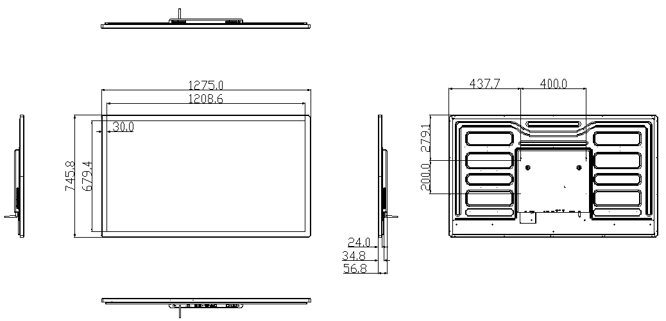

Chapter V. Packaging Portion

5.1. Packing Size
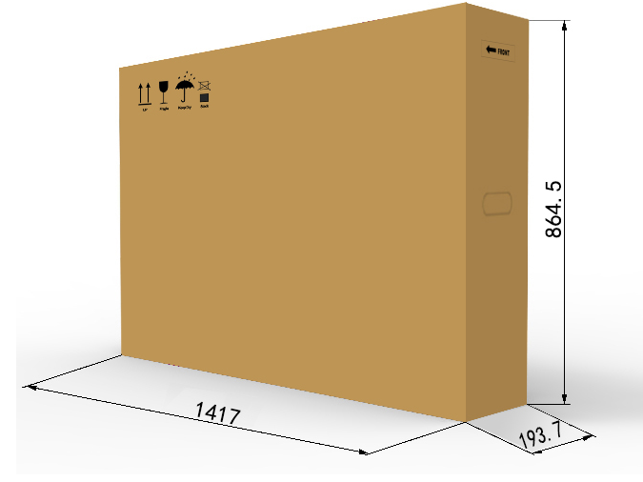

5.2. Packaging Drawings

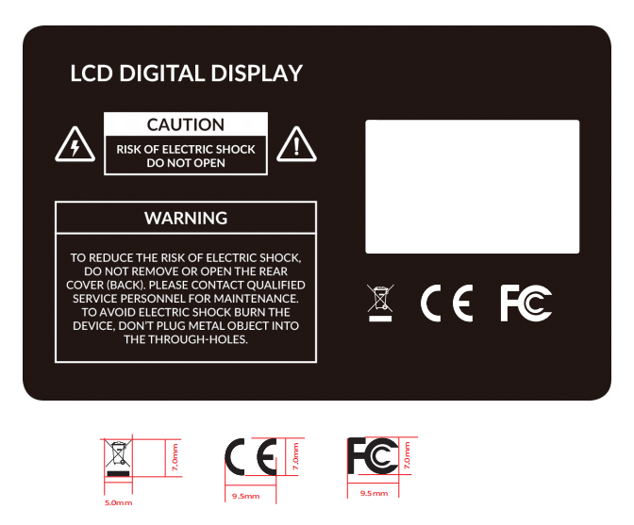5.3. Nameplate

5.4. Labels

5.4.1. Nameplate Labels
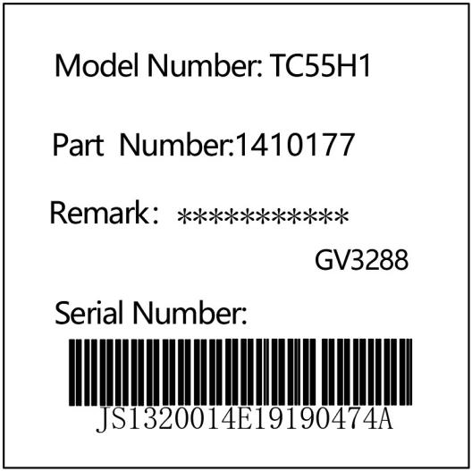

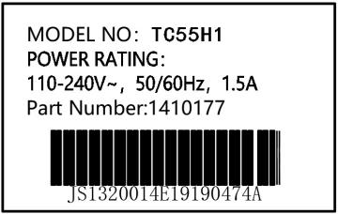

Chapter VI. Environmental Requirement

6.1. Operating Temperature
Item | Symbol | Values |  |  | Unit | Note
 |  | Min | Typ | Max
Operating Temperature | Hop | 0 | - | 40 | ℃
Operating Ambient Humidity | Hop | 10% | - | 80% | RH | Relative humidity (non-condensing).

6.2. Storage Temperature
Item | Symbol | Values |  |  | Unit | Note
 |  | Min | Typ | Max
Storage Temperature | HST | -10 | - | 55 | ℃
Storage Humidity | HST | 10 | - | 80% | RH | relative humidity (non-condensing).

Chapter VII. ID Rendering

7.1. Six Sides Figure
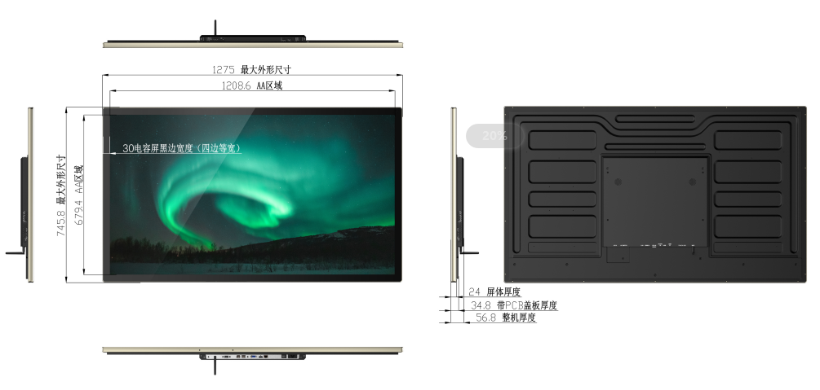

7.2. Front View

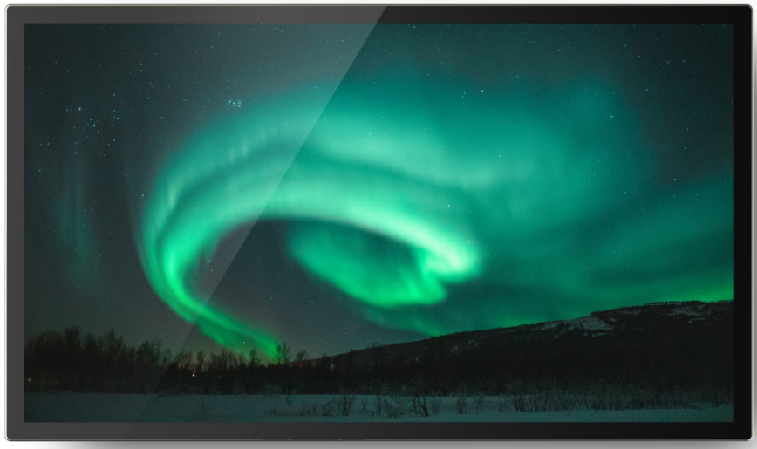

7.3. Back View

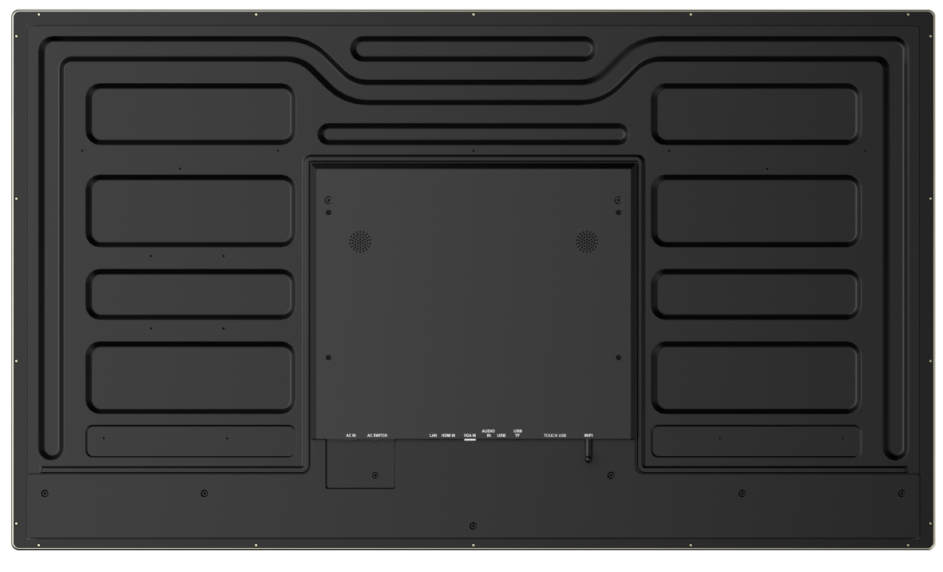

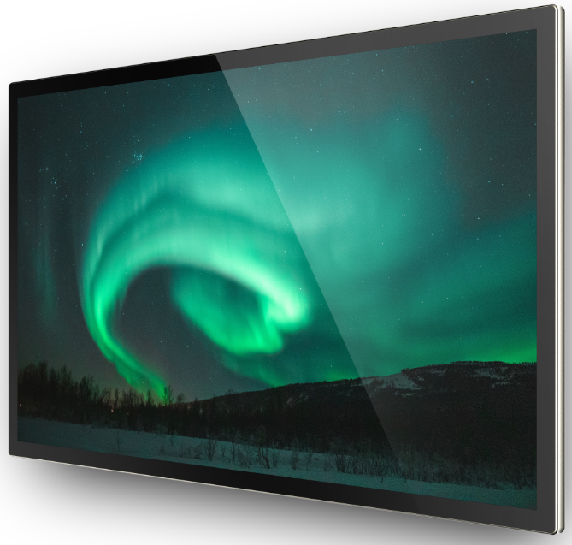
7.4. End View

7.5. Interface Rear View

