Shanghai Goodview Electronic Technology Co., Ltd.
Specification
M43FUH

Sign and Date by: ___________ Sign and Date by: ____________

Customer GoodView

Content
Chapter I. Revision History 2
Chapter II. Summary 3
2.1. Statement 3
2.2. Safety instructions 4
Chapter III. Product Parameter 5
3.1. Main Technical Parameters 5
3.2. LCD Panel Technical Parameters 7
3.3. Input Signal 8
3.3.1. HDMI Port 8
3.3.2 VGA Port 8
3.4.1. AC Input Electrical Characteristics 9
3.4.2. Green mode function 9
3.5. External Interface Portion 10
Chapter IV. Mechanical Portion 11
4.1. Outline drawing 11
Chapter V. Packaging Portion 12
5.1. Packing Size 12
5.2. Packaging Drawings 13
5.3. Nameplate 13
5.4. Labels 13
5.4.1. Nameplate Labels 13
Chapter VI. Environmental Requirement 15
6.1. Operating Temperature 15
6.2. Storage Temperature 15
Chapter VII. ID Rendering 16
7.1. Six Sides Figure 16
7.2. Front View 17
7.3. Back View 17
7.4. End View 18
7.5. Interface Rear View 18

Chapter I. Revision History
Parts No. | Version | Revision History | Date | Written by | Auditing | Approval
1270100 | V1.0 | First issue | 2022/9/21 |  | /

Chapter II. Summary

2.1. Statement
All parts of this product, including accessories and software, all the intellectual property right are owned by Shanghai Goodview Electronic Technology Co., Ltd. (hereinafter refers to "Goodview") or authorizes the relevant subjects xxxx to use. Without the permission of the right subjects, no copying or translation is allowed.
There is no any form of guarantee, position expression or other implication in this manual, if there is any direct or indirect loss of data, loss of profits or termination of business caused by the product information mentioned in this manual, Goodview and its employees are not liable for it. In addition to this, the product specifications and information mentioned in this manual are only for reference and will be updated at any time without further notice. Faults or damages caused by the following factors are not covered by free warranty:
- Damage caused by natural disasters (floods, fires, earthquakes, lightning strikes, typhoons, etc.), force majeure or inadvertent use of man-made operations.
- Self-assemble, repair, or send the product to a maintenance shop not authorized or certified by Goodview for inspection and repair.
- Damages and faults caused by users who may or request a third party to modify, repair, alter specifications and install, add and expand parts that are not sold, authorized or approved by our company without authorization.
- Usage problems and faults caused by improper installation and setting of software by users themselves.
- Problems and malfunctions caused by computer viruses.
- Warranty identification label of our company is torn or unrecognizable.
- Other problems and faults caused by abnormal use.
The product names mentioned in the user's manual are only for identification, and these names may belong to registered trademarks or copyrights of other companies.

Goodview reserves the right to change any or all specifications without notice. The information contained in this document is subject to change without notice.

For the latest upgrade information of product specifications, please call to Shanghai Goodview Electronic Technology Co., Ltd.

2.2. Safety instructions
Safety of Electrical
- In order to avoid serious damage caused by possible electric shock, please remove the power cord of the equipment temporarily from the power socket before moving the equipment
- When you want to add or remove the hardware device in the system, you must connect the data line of the device first and then the power line. If possible, unplug the power cord of the device before installing the hardware device.
- Before you connect or unplug any data lines from the module, make sure that all the power lines have been unplugged beforehand.
- Before using an extension card or an adapter card, we suggest that you seek for professional assistance first. These devices may interfere with the grounding circuit.
- Make sure that the voltage settings of the power supply have been adjusted to the voltage standard values used in the country/region. If you are not sure what the supply voltage value is in your area, please ask the local power company personnel nearby.
- If the power supply is damaged, please do not attempt to repair it by yourself. Please seek the help of professional technical service personnel.
Safety in operation
- Before you install modules and add hardware devices, be sure to read the relevant information provided in this manual in detail.
- Before using the product, make sure that all the data lines and power lines are connected correctly. If you find any defects, please contact Goodview as soon as possible.
- In order to avoid electrical short circuit, make sure that all unused screw, paper clip and other parts are put away, and do not leave them on the module or in the equipment.
- Dust, moisture and drastic temperature changes will affect the life of the motherboard, so please try to avoid placing them in these places.
- Do not place the equipment in a place that is easy to shake.
- If there are any technical problems in the use of this product, please contact the technicians who have been verified or experienced.

Chapter III. Product Parameter

3.1. Main Technical Parameters
NO | Subtype | Name |  | Parameter |  |  |  |  |  |  |  | Unit | Note
1 | Product  Parameter | Panel |  | 42.5 inches LED backlight
2 |  | Product size (mm) |  | 957(H)×547(V)×64.1(D) |  |  |  |  |  |  |  | mm
3 |  | Active size (mm) |  | 941.184(H) x529.416 (V) |  |  |  |  |  |  |  | mm
4 |  | Color |  | Black
5 |  | Weight (Gross) |  | 18.2 |  |  |  |  |  |  |  | KG
6 |  | Weight (Net) |  | 15.3 |  |  |  |  |  |  |  | KG
7 |  | Speaker |  | 2×2W 4Ω |  |  |  |  |  |  |  | Watt
8 |  | Screen hanging mode |  | Portrait,Landscape
9 |  | Play mode |  | HorizontalSplit display Vertical Play List
10 |  | OSD Language |  | Chinese\English
11 |  | Multimedia transmission |  | USB,LAN,WLAN
12 | Function | Smart volume |  | Support
13 |  | Watch dog |  | Support
14 |  | Timer |  | Multi time interval timing switch on/off
15 |  | Management software |  | C/S framework: ADPE/Ezposter  B/S framework: GTV Information Distribution System
16 | Core | CPU |  | T972-SR Quad-Core A55 1.9GHz
17 |  | GPU |  | Mali-G31 MP2 GPU
18 |  | Memory |  | 2GB
19 |  | Storage |  | 8G eMMC
20 |  | Operation System |  | Android 9.0
21 | Multimedia | Picture | Extension | Format |  | Maximum resolution |  |  | Minimum resolution |  | Format
 |  |  |  | png |  | 8K*8K |  |  | 4*4 |  | png
 |  |  |  | jpg |  | 8K*8K |  |  | 4*4 |  | jpeg
 |  |  |  | bmp |  | 8K*8K |  |  | 4*4 |  | bmp
 |  |  |  | gif |  | 3.6K*3.6K |  |  | 4*4 |  | gif
22 |  | Audio | Extension | Format |  | Maximum resolution |  |  | Minimum resolution |  | Format
 |  |  |  | WindowsMediaAudio(.wma) |  | WMA* |  |  | 8KHz ~ 96Khz |  | 8bps ~ 320Kbps
 |  |  |  | MPEG Audio Layer III (.mp3) |  | MPEG |  |  | 8kHz ~ 48kHz |  | 8kbps ~ 320kbps
 |  |  |  | Wave Audio Files (.wav) |  | PCM |  |  | max 48kHz |  | Max 1.5Mbps
 |  |  |  |  |  | ADPCM |  |  | max 48kHz |  | Max 1.5Mbps
 |  |  |  | Matroska Audio (.mka) |  | WavPack |  |  | max 44.1kHz |  | VBR
 |  |  |  | Xiph.org OGG Audio(.ogg) |  | Vorbis |  |  | 8 ~ 96 kHz |  | n.a
 |  |  |  | Xiph.org FLAC Audio(.flac) |  | Flac |  |  | 8 ~ 96 kHz |  | VBR
 |  |  |  | Monkey’s Audio(.ape) |  | APE* |  |  | 8 ~ 48 kHz |  | VBR
 |  |  |  | Dolby Digital (Contained in VIDEO file) |  | DD* |  |  | Up to 640kbps |  | 32~48kHz
 |  |  |  | Dolby Digital Plus(Contained in VIDEO  file) |  | DD+* |  |  | Up to 3024kbps |  | 32~48kHz
 |  |  |  | Digital Theater Systems (DTS) DIGITAL  SURROUND，(Contained in VIDEO file) |  | DTS*, DTS ES* |  |  | Up to 1509kbps |  | 32~48kHz
 |  |  |  | Digital Theater Systems (DTS) HD， (Contained in VIDEO file) |  | DTS-HD High Resolution*, Master  Audio* |  |  | n.a |  | 32~96kHz
 |  |  |  | Digital Theater Systems (DTS)  Express，(Contained in VIDEO file) |  | DTS-Express (7.1)* |  |  | n.a |  | 32~48kHz
 |  |  |  | Windows Media Audio(.WMA) |  | WMA 7*, WMA 8*,WMA  9*(Non-support Loseless/MBR) |  |  | 8 ~ 320 kbps, CBR and VBR |  | 8 ~ 96 kHz
23 |  | Video | Extension | MPEG1, MPEG2, MPEG4, WMV, MKV, AVI, TS, flv and other mainstream video formats
 |  |  | encoder | File format (File | video format |  | Highest code rate | Frame rate |  | resolution ratio
 |  |  |  | AVI | MPEG-4 ASP |  | n.a | 30FPS |  | 1920x1080
 |  |  |  |  | Divx3* |  | n.a | 30FPS |  | 720x576
 |  |  |  |  | Divx4* |  | n.a | 24FPS |  | 1920x1080
 |  |  |  |  | Divx5* |  | n.a | 30FPS |  | 1920x1080
 |  |  |  |  | Xvid |  | n.a | 30FPS |  | 1920x1080
 |  |  |  |  | MJPEG |  | n.a | 30FPS |  | 1920x1080
 |  |  |  |  | AVC/H.264 |  | n.a | 30FPS |  | 1920x1080
 |  |  |  | MPEG-2 TS Transport Stream (.ts) | MPEG-1 |  | n.a | 60FPS |  | 1920x1080
 |  |  |  |  | MPEG-2 |  | n.a | 60FPS |  | 1920x1080
 |  |  |  |  | AVC/H.264 |  | 100Mbps | 30FPS |  | 3840x2160
 |  |  |  |  | HEVC/H.265（H.265 Main 10） |  | 80Mbps | 60FPS |  | 3840x2160
 |  |  |  |  | AVS+（AVS-P16） |  | n.a | 30FPS |  | 1920x1080
 |  |  |  |  | AVS（AVS-P2 Jizhun） |  | n.a | 30FPS |  | 720x576
 |  |  |  | MPEGFile Format | MPEG-1 |  | n.a | 60FPS |  | 1920x1080
 |  |  |  |  | MPEG-2 |  | n.a | 60FPS |  | 1920x1080
 |  |  |  |  | VC-1* |  | n.a | 24FPS |  | 1920x1080
 |  |  |  | mpg | MPEG-1 |  | n.a | 60FPS |  | 1920x1080
 |  |  |  |  | MPEG-2 |  | n.a | 60FPS |  | 1920x1080
 |  |  |  | MPEG-4 Part 14 (.mp4) | MPEG-4 ASP |  | n.a | 60FPS |  | 1920x1080
 |  |  |  |  | H.263 |  | n.a | 30FPS |  | 720x576
 |  |  |  |  | AVC/H.264 |  | 100Mbps | 30FPS |  | 3840x2160
 |  |  |  |  | HEVC/H.265（H.265 Main 10） |  | 80Mbps | 60FPS |  | 3840x2160
 |  |  |  | QuickTime | MPEG-4 ASP |  | n.a | 60FPS |  | 1920x1080
 |  |  |  |  | H.263 |  | n.a | 30FPS |  | 720x576
 |  |  |  |  | AVC/H.264 |  | 100Mbps | 30FPS |  | 3840x2160
 |  |  |  | BDAV MPEG-2 transport stream (.m2ts) | AVC/H.264 |  | n.a | n.a |  | nonsupport 4K
 |  |  |  |  | VC-1* |  | n.a | 24FPS |  | 1920x1080
 |  |  |  | Matroska (.mkv) | AVC/H.264 |  | 100Mbps | 30FPS |  | 3840x2160
 |  |  |  |  | HEVC/H.265（H.265 Main 10） |  | 80Mbps | 60FPS |  | 3840x2160
 |  |  |  |  | Windows Media Video(WMV)  9* |  | n.a | 30FPS |  | 1280x720
 |  |  |  |  | VP9 Profile-2 |  | 60Mbps | 60FPS |  | 3840x2160
 |  |  |  | Flash Video (.flv) | AVC/H.264 |  | n.a | n.a |  | nonsupport 4K
 |  |  |  | webm | VP9 Profile-2 |  | 60Mbps | 60FPS |  | 3840x2160
 |  |  |  | Video OBject (.vob) | MPEG-2 |  | n.a | 60FPS |  | 1920x1080
 |  |  |  | DAT (.dat) | MPEG-1 |  | n.a | 60FPS |  | 1920x1080
 |  |  |  | MPEG-4 Part 14 (.m4v) | AVC/H.264 |  | n.a | n.a |  | nonsupport 4K
 |  |  |  | Advanced Stream Format (.asf) | Windows Media Video(WMV)  9* |  | n.a | 30FPS |  | 320x240  30fps
 |  |  |  | Flash Video, Based On MPEG-4 Part  12 (.f4v) | AVC/H.264 |  | n.a | n.a |  | nonsupport 4K
 |  |  |  | 3gp | H.263* |  | n.a | 30FPS |  | 720x576
 |  |  |  |  | MPEG-4 ASP |  | n.a | 30FPS |  | 1920x1080
 |  |  |  | 3g2 | H.263* |  | n.a | 30FPS |  | 720x576
 |  |  |  | tp | MPEG-2 |  | n.a | 60FPS |  | 1920x1080
 |  |  |  | rmvb | Real Video 8* |  | n.a | 24FPS |  | 1280x720
 |  |  |  |  | Real Video 9/10* |  | n.a | 60FPS |  | 1920x1080
 |  |  |  | ogm | Divx5* |  | n.a | 30FPS |  | 1920x1080
 |  |  |  |  | Xvid |  | n.a | 30FPS |  | 1920x1080
 |  |  |  | rm | Real Video 8* |  | n.a | 24FPS |  | 1280x720
 |  |  |  |  | Real Video 9/10* |  | n.a | 60FPS |  | 1920x1080
 |  | Text | Extension | .txt
 |  | HTMI 5 |  | Support |  |  |  |  |  |  |  | mm
24 | Installation | Installation mode |  | 400x200 &400x400 （Screw type M6×10mm）
 |  | VESA standard |  | VESA installation
25 | Accessories |  |  | - AC power line×1  - Remote control×1  - AAA battery×2  - WIFI antenna×1  - M6 * 28+6 hexagonal spacing column × 4  - M6 * 10 machine screw× 4
26 | Certification

3.2. LCD Panel Technical Parameters
 |  | Symbol | Parameter |  |  | Unit | Note
 |  |  | Min | Typ | Max
LCD Panel Size |  |  | - | 42.5 | - | inches | Led backlight
Active Screen Size |  |  | 941.184(H) x529.416 (V) |  |  | mm
Pixel Format |  |  | 3840×2160 |  |  | Pixels
Panel Luminance |  |  | 630 | 700 |  | cd/m2
Contrast Ratio |  | CR | - | 500 | -
Color Depth |  |  | 1.07 G colors
Pixel Pitch |  |  | 0.0817(H)x 0.2451(V) |  |  | mm
Color temperature |  |  |  | TBD
Color Gamut |  |  |  | 72% |  | %
Response Time |  | G to G BW | - | 6.5 | - | ms
Backlight Life Time |  |  | 30000 | - | - | Hrs
Viewing Angle | Xaxis,right=0° | R | - | 89 | -
 | x axis, left=180° | L | - | 89 | -
 | y axis, up =90° | U | - | 89 | -
 | yaxis, down=270° | D | - | 89 | -

3.3. Input Signal

HDMI Port
signal source | resolution ratio
4K2K(HDMI 1&2&3) | 480i, 480p, 720p, 1080i, 1080p, 2160P

3.4. Specification Overview

3.4.1. AC Input Electrical Characteristics

Item | Symbol | Values |  |  | Unit | Note
 |  | Min | Typ | Max
AC Power Input Voltage | AC IN | 100 | 220 | 240 | VAC
AC Power Input Current | TBD | - | - | 1.6A | AAC
Power Consumption | TBD | - | - | 94 | Watt

3.4.2. Green mode function

Item | Symbol | Values |  |  | Unit | Note
 |  | Min | Typ | Max
Stand-by power consumption | TBD | / | / | 0.5 | Watt

3.5. External Interface Portion
NO | Subtype | Name | Number | Parameter
1 | Ac input | Coupler | ×1 | Plum shaped tail
2 |  | AC Switch | ×1 | Rocker switch
3 | Control  Terminals | HDMI | ×3 | HDCP Version:1.4/2.2
4 |  | Ethernet RJ45 | ×1 | 10M/100M Ethernet
5 |  | WiFi | ×1 | 2.4G802.11b/g/n/ac
6 |  | USB2.0 | ×2 | USB HOST

Chapter IV. Mechanical Portion

4.1. Outline drawing
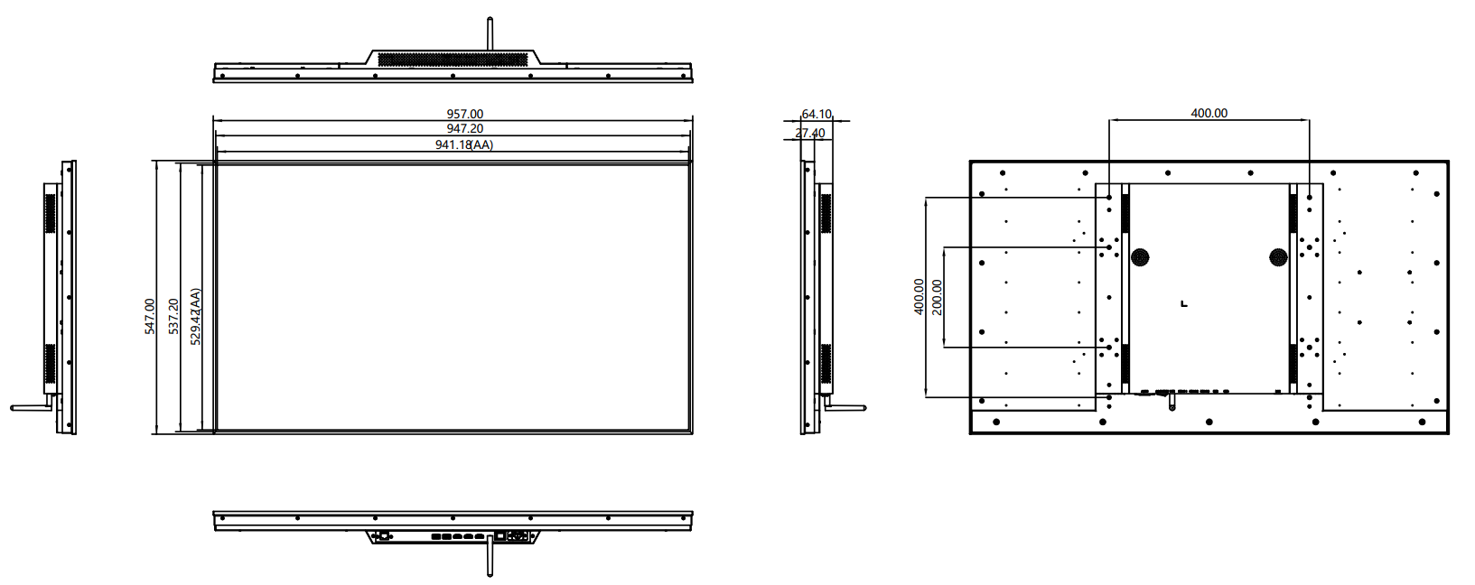

Chapter V. Packaging Portion

5.1. Packing Size

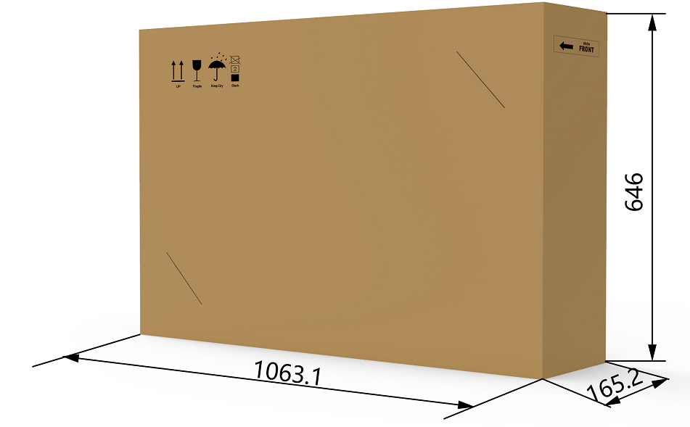

5.2. Packaging Drawings
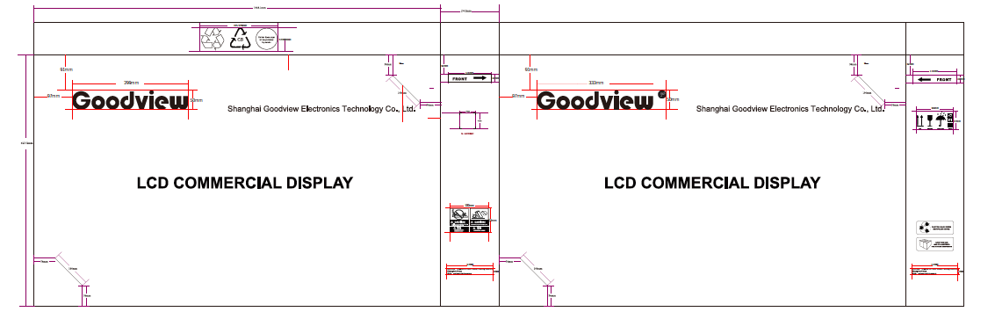

5.3. Nameplate

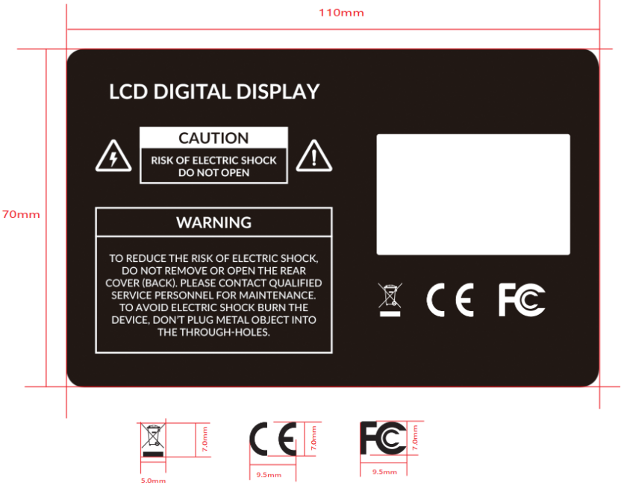

5.4. Labels

5.4.1. Nameplate Labels

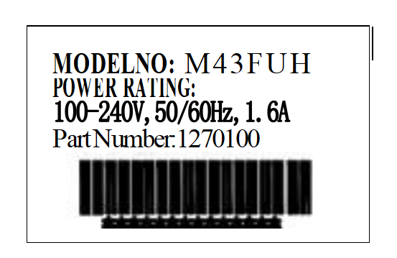
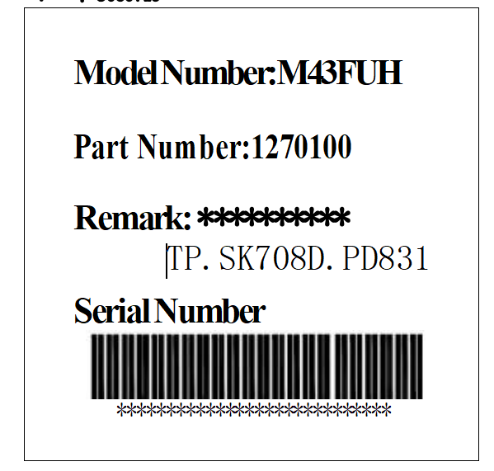

Chapter VI. Environmental Requirement

6.1. Operating Temperature
Item | Symbol | Values |  |  | Unit | Note
 |  | Min | Typ | Max
Operating Temperature | Hop | 0 | - | 40 | ℃
Operating Ambient Humidity | Hop | 10% | - | 80% | %RH | Relative humidity (non-condensing).

6.2. Storage Temperature
Item | Symbol | Values |  |  | Unit | Note
 |  | Min | Typ | Max
Storage Temperature | HST | -10 | - | 55 | ℃
Storage Humidity | HST | 10 | - | 80% | RH | relative humidity (non-condensing).

Chapter VII. ID Rendering

7.1. Six Sides Figure
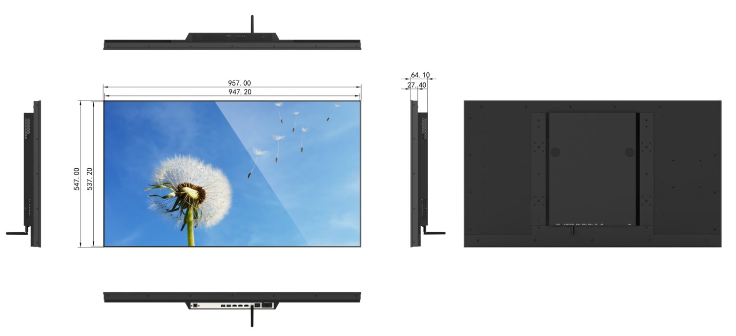

7.2. Front View

7.3. Back View

7.4. End View
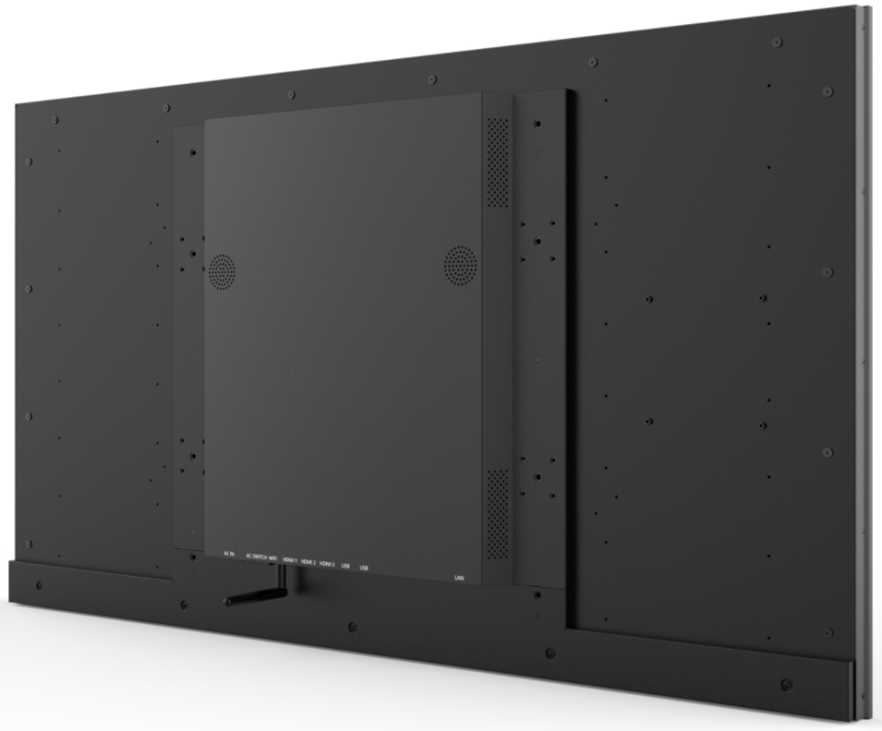

7.5. Interface Rear View

