Shanghai Goodview Electronic Technology Co.,Ltd
Specification
L49H10C
Sign and Date by: ___________ Sign and Date by: ____________

Customer Good View

Contents
Contents 1
Chapter 1. Revision History 1
Chapter 2. Summary 2
1.1. 2.1. Statement 2
1.2. 2.2. Safety instructions 3
Chapter 3. Product Parameter 4
3.1. Main Technical Parameters 4
3.2. LCD Panel Technical Parameters 6
3.3. Input Signal 7
3.3.1. HDMI Port 7
3.3.2. VGA Port 7
3.4. Specification Overview 8
3.4.1. AC Input Electrical Characteristics 8
3.4.2. Green mode function 8
3.5. External Interface Portion 9
Chapter 4. Mechanical Portion 9
4.1. Outline Drawing 9
Chapter 5. Packaging Portion 11
5.3 Packing Size 11
Chapter 6. Nameplate 11
Chapter 7. Labels 12
Chapter 8. Environmental Requirement 12
8.1. Operating Temperature 12
8.2. Storage Temperature 12
Chapter 9. ID Rendering 13
9.1. Six Sides Figure 13
9.2. Front View 14
9.3. Back View 15
9.4. End View 16
9.5. Interface Rear View 17

Chapter 1. Revision History
Product No. | Version | Revision History | Released Date | Written By | Audit | Approved
1410180 | V1.0 | First Issue | 2022/4/2 |  |  | 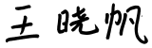

Chapter 2. Summary

2.1. Statement
All parts of this product, including accessories and software, all the intellectual property right are owned by Shanghai Goodview Electronic Technology Co., Ltd. (hereinafter refers to "Goodview") or authorizes the relevant subjects xxxx to use. Without the permission of the right subjects, no copying or translation is allowed.
There is no any form of guarantee, position expression or other implication in this manual, if there is any direct or indirect loss of data, loss of profits or termination of business caused by the product information mentioned in this manual, Goodview and its employees are not liable for it. In addition to this, the product specifications and information mentioned in this manual are only for reference and will be updated at any time without further notice. Faults or damages caused by the following factors are not covered by free warranty:
- Damage caused by natural disasters (floods, fires, earthquakes, lightning strikes, typhoons, etc.), force majeure or inadvertent use of man-made operations.
- Self-assemble, repair, or send the product to a maintenance shop not authorized or certified by Goodview for inspection and repair.
- Damages and faults caused by users who may or request a third party to modify, repair, alter specifications and install, add and expand parts that are not sold, authorized or approved by our company without authorization.
- Usage problems and faults caused by improper installation and setting of software by users themselves.
- Problems and malfunctions caused by computer viruses.
- Warranty identification label of our company is torn or unrecognizable.
- Other problems and faults caused by abnormal use.
The product names mentioned in the user's manual are only for identification, and these names may belong to registered trademarks or copyrights of other companies.

Goodview reserves the right to change any or all specifications without notice. The information contained in this document is subject to change without notice.

For the latest upgrade information of product specifications, please call to Shanghai Goodview Electronic Technology Co., Ltd.

2.2. Safety instructions
Safety of Electrical
- In order to avoid serious damage caused by possible electric shock, please remove the power cord of the equipment temporarily from the power socket before moving the equipment
- When you want to add or remove the hardware device in the system, you must connect the data line of the device first and then the power line. If possible, unplug the power cord of the device before installing the hardware device.
- Before you connect or unplug any data lines from the module, make sure that all the power lines have been unplugged beforehand.
- Before using an extension card or an adapter card, we suggest that you seek for professional assistance first. These devices may interfere with the grounding circuit.
- Make sure that the voltage settings of the power supply have been adjusted to the voltage standard values used in the country/region. If you are not sure what the supply voltage value is in your area, please ask the local power company personnel nearby.
- If the power supply is damaged, please do not attempt to repair it by yourself. Please seek the help of professional technical service personnel.
Safety in operation
- Before you install modules and add hardware devices, be sure to read the relevant information provided in this manual in detail.
- Before using the product, make sure that all the data lines and power lines are connected correctly. If you find any defects, please contact Goodview as soon as possible.
- In order to avoid electrical short circuit, make sure that all unused screw, paper clip and other parts are put away, and do not leave them on the module or in the equipment.
- Dust, moisture and drastic temperature changes will affect the life of the motherboard, so please try to avoid placing them in these places.
- Do not place the equipment in a place that is easy to shake.
- If there are any technical problems in the use of this product, please contact the technicians who have been verified or experienced.

Chapter 3. Product Parameter

3.1. Main Technical Parameters

NO | Subtype | Name |  | Parameter | Unit | Note
1 |  | Panel |  | 49 inches LED
2 | Parameters | Product Size(mm) |  | 1870.1(H)×665.6(V)×41.2 | mm
3 |  | Active Size(mm) |  | 1072.78mm(H) ×603mm(V)） | mm
4 |  | Color |  | White
5 |  | Gross Weight |  | 78 | KG
6 |  | Net Weight |  | 58 | KG
7 |  | Speaker Power |  | Stereo 2×10W 4Ω | Watt
8 |  | Orientation |  | Portrait
9 |  | OSD Language |  | Chinese/English
10 |  | Playmode |  | Playlist, Multi Window play
11 |  | Media Transferring |  | USB, WAN, LAN
12 | Function | Smart Volume |  | Set Volume Based on Time
13 |  | WatchDOG |  | Supported
14 |  | Time Control |  | Multi Time period Auto On/Off
15 |  | Management software |  | GTV C/S structure, ADPE/Ezposter B/S structure GTV publishing system
16 | Core | CPU |  | RK 3288 Quadcore ARM Cortex A17  (Maximum 1.6GHz)
17 |  | GPU |  | QuadCore ARMMail-764
18 |  | RAM |  | DDR3 2GB
19 |  | ROM |  | 8G eMMC
20 |  | OS |  | Android 7.1
21 | Touching Frame | Model |  | 49 Touching Panel
22 |  | Touching Type |  | Capacitive
23 |  | Touching Points |  | 10 points
24 |  | Touching Resolution |  | 32767×32767
25 |  | Accuracy |  | More than 90% area is ±2mm
26 |  | Response Time |  | <15ms
27 |  | Input Way |  | Fingers, Pens and other objects
39 | Media | Pics | Extension | *.jpg, *.jpeg, *.gif, *.bmp, *.png | TBD
40 |  | Audio | Extension | *.mp3
41 |  | Video | Extension | .MPEG1,MPEG2,MPEG4,WMV,MKV,AVI,TS,flv etc
42 |  | Text | Extension | .txt
43 |  | HTMI 5 |  | Supported
45 |  | Installation |  | Floor Standing
46 | Accessories |  |  | - Power cable ×1  - M8 cushion×14  - M8 screw×14  - Key x1  - Remote control x1  - AAA battery x2

3.2. LCD Panel Technical Parameters
 |  | Symbol | Parameter |  |  | Unit | Note
 |  |  | Min | Typ | Max
LCDPanel Siz |  |  | - | 48.5 | - | inches | Led
Active Screen Size |  |  | 1073.8 * 604.0 |  |  | mm
Pixel Format |  |  | 1920*1080 |  |  | Pixels
Panel Luminance |  |  | - | 400 | - | cd/m2
Production Luminance |  |  |  | 340 |  | cd/m2
Contrast Ratio |  | CR | - | 1200 | -
Color Depth |  |  | 8bit, 16.7 Million colors
Pixel Pitch |  |  | 0.18642*0.55926 |  |  | mm
Color Temperature |  |  |  | / |  | K
Color Gamut |  |  |  | 68 |  | %
Response Time |  | G to G BW | - | 8 | - | ms
Backlight Life Time |  |  | 15000 | - | - | Hrs
Viewing Angle | x axis,right=0° | R | 89 | - | -
 | x axis, left=180° | L | 89 | - | -
 | y axis, up =90° | U | 89 | - | -
 | y axis, down=270° | D | - | 89 | -

3.3. Input Signal

3.3.1. HDMI Port
Resolution | Refresh
1024x768 | @60Hz/50Hz
1600x900 | @60Hz/50Hz
1280x800 | @60Hz/50Hz
1280x720 | @60Hz/50Hz
1280x1024 | @60Hz/50Hz
1360x768 | @60Hz/50Hz
1366x768 | @60Hz/50Hz
1440x900 | @60Hz/75Hz
1680x1050 | @60Hz/50Hz
1920x1080 | @60Hz/50Hz

3.3.2. VGA Port
Resolution | Refresh
1024x768 | @60Hz/50Hz
1600x900 | @60Hz/50Hz
1280x800 | @60Hz/50Hz
1280x720 | @60Hz/50Hz
1280x1024 | @60Hz/50Hz
1360x768 | @60Hz/50Hz
1366x768 | @60Hz/50Hz
1440x900 | @60Hz/75Hz
1680x1050 | @60Hz/50Hz
1920x1080 | @60Hz/50Hz

3.4. Specification Overview

3.4.1. AC Input Electrical Characteristics
Item | Symbol | Values |  |  | Unit | Note
 |  | Min | Typ | Max
ACPower Input Voltage | AC IN | 110 | 220 | 240 | VAC
AC Power Input Current |  | / | / | 1.6 | AAC
Power Consumption |  | / | / | 115 | Watt

3.4.2. Green mode function
Item | Symbol | Values |  |  | Unit | Note
 |  | Min | Typ | Max
Standby Power Consumption |  | / | / | 0.5 | Watt

3.5. External Interface Portion
NO | Subtype | Name | Number | Parameter
 | Ac input | Coupler | ×1 | Up and Twin sided bottom
 |  | AC Switch | ×1 | Rocker Switch
 | Control  Terminals | USB2.0 | ×2 | USB HOST  USB OTG
 |  | EthernetRJ45 | ×1 | 100M Ethernet
 |  | WiFi  Bluetooth | ×1 | 2.4G/5G 802.11b/g/n/ac  Bluetooth 4.2
 |  | Extension Storage | ×1 | Micro TF Card 32G (Max)

Chapter 4. Mechanical Portion

4.1. Outline Drawing

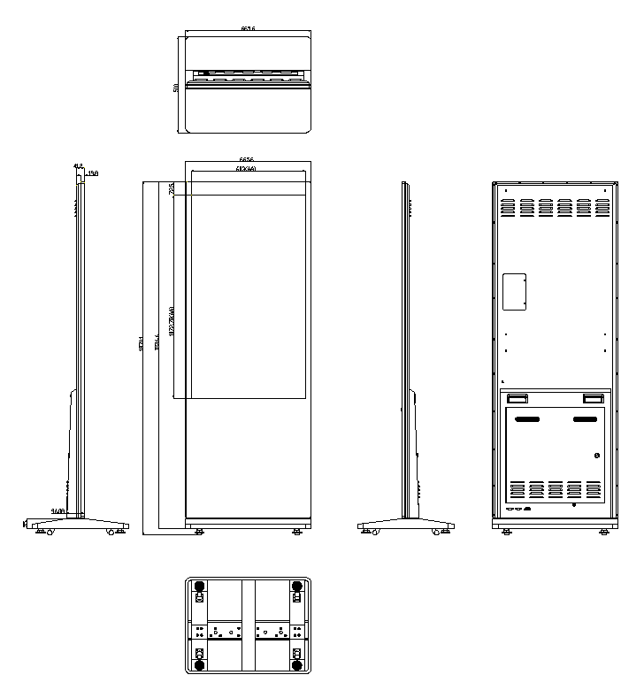

Chapter 5. Packaging Portion

5.3 Packing Size
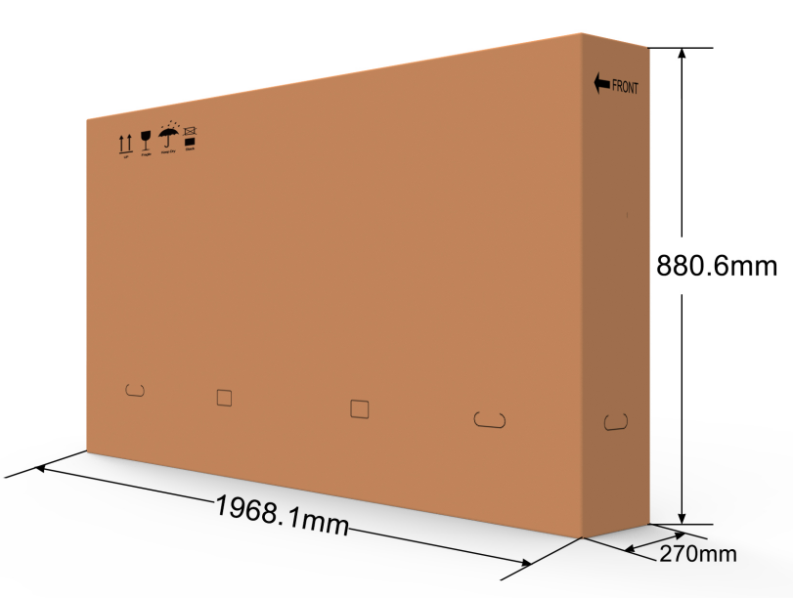

Chapter 6. Nameplate
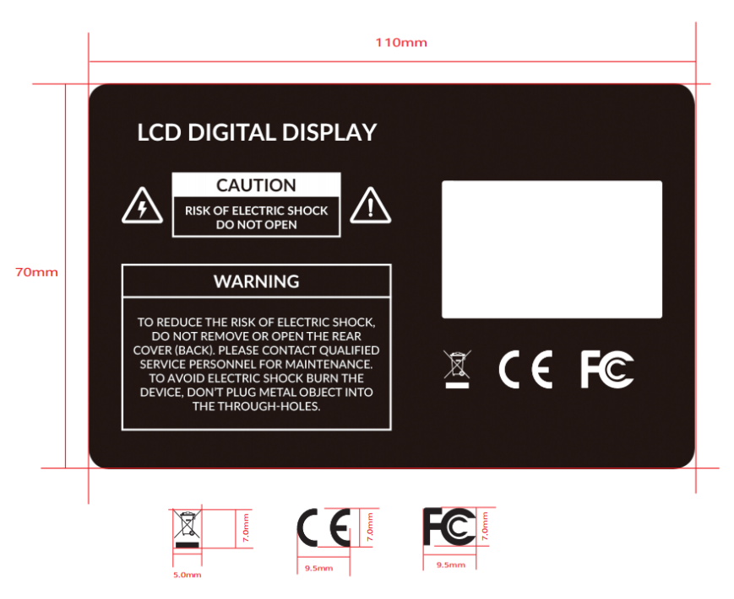

Chapter 7. Labels
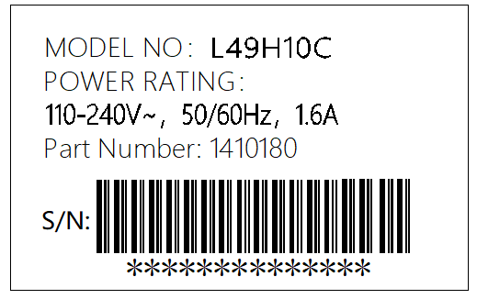
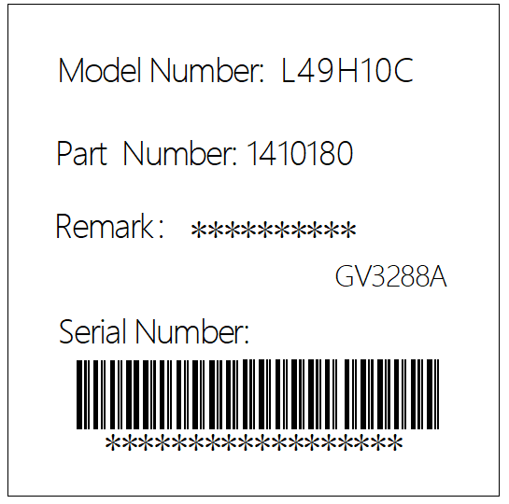

Chapter 8. Environmental Requirement

8.1. Operating Temperature
Item | Symbol | Values |  |  | Unit | Note
 |  | Min | Typ | Max
Operating Temperature | Hop | 0 | / | 40 | ℃
Operating Ambient Humidity | Hop | 10% | / | 80% | %RH | Relative humidity (non-condensing).

8.2. Storage Temperature
Item | Symbol | Values |  |  | Unit | Note
 |  | Min | Typ | Max
Storage Temperature | HST | -10 | / | 55 | ℃
Storage Humidity | HST | 10 | / | 80% | %RH | relative humidity (non-condensing).

Chapter 9. ID Rendering

9.1. Six Sides Figure
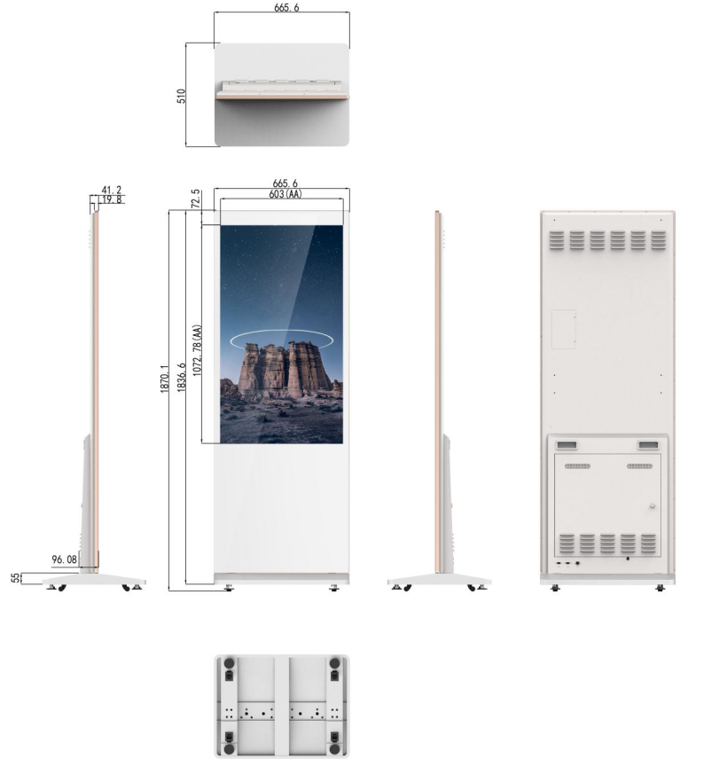

9.2. Front View
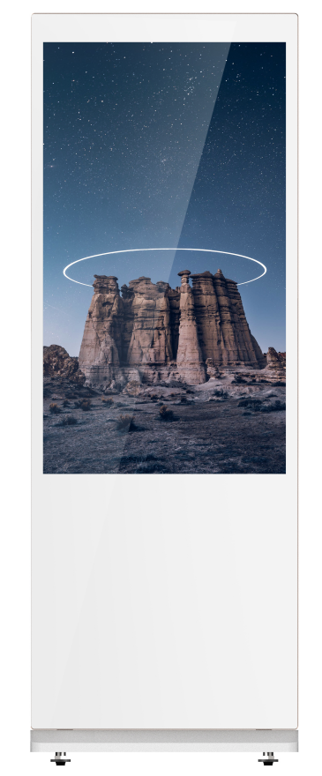

9.3. Back View
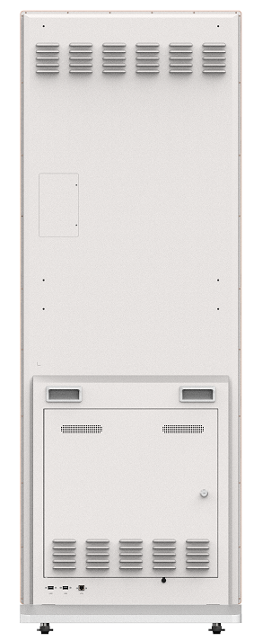

9.4. End View
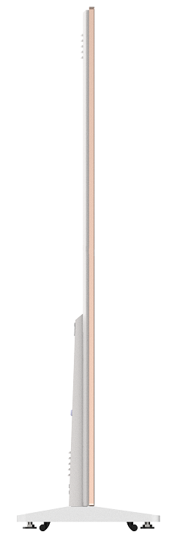

9.5. Interface Rear View

