Shanghai Goodview Electronic Technology Co.,Ltd.
Specification
GM75L1
Sign and Date by: ___________ Sign and Date by: ____________

Customer Good View

Contents
Contents 1
Chapter 1 Revision History 2
Chapter 2 Summary 3
2.1. Statement 3
2.2. Safety instructions 4
Chapter 3 Product Parameter 5
3.1. Main Technical Parameters 5
3.1. LCD Panel Technical Parameters 7
3.2. Input Signal 7
3.2.1. HDMI Port 7
3.3. Specification Overview 8
3.3.1. AC Input Electrical Characteristics 8
3.3.2. Green mode function 8
3.4. External Interface Portion 8
Chapter 4. Mechanical Portion 9
4.1. Outline drawing 9
Chapter 5. Packaging Portion 10
5.1. Packing size 10
5.2. Packaging Drawings 11
5.3. Labels & Barcode 11
5.3.1. Nameplate 11
5.3.2. Packing Label 12
Chapter 6. Environmental Requirement 12
6.1. Operating Temperature 12
6.2. Storage Temperature 12
Chapter 7. ID Rendering 13
7.1. Six Sides Figure 13
7.2. Front View 13
7.3. Reverse View 14
7.4. Side View 15
7.5. Interface View 15

Chapter 1 Revision History
Product No. | Version | Revision History | Released Date | Written By | Audit | Approve
1440117 | V1.0 | First Issue | 2020/5/12 | 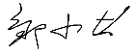 |  | 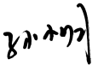
1440117 | V2.0 | Change product color | 2020/8/3 |  | 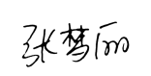
1440117 | V3.0 | Modify Nameplate | 2021/1/14 | 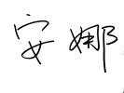

Chapter 2 Summary

2.1. Statement
All parts of this product, including accessories and software, all the intellectual property right are owned by Shanghai Goodview Electronic Technology Co., Ltd. (hereinafter refers to "Goodview") or authorizes the relevant subjects xxxx to use. Without the permission of the right subjects, no copying or translation is allowed.
There is no any form of guarantee, position expression or other implication in this manual, if there is any direct or indirect loss of data, loss of profits or termination of business caused by the product information mentioned in this manual, Goodview and its employees are not liable for it. In addition to this, the product specifications and information mentioned in this manual are only for reference and will be updated at any time without further notice. Faults or damages caused by the following factors are not covered by free warranty:
- Damage caused by natural disasters (floods, fires, earthquakes, lightning strikes, typhoons, etc.), force majeure or inadvertent use of man-made operations.
- Self-assemble, repair, or send the product to a maintenance shop not authorized or certified by Goodview for inspection and repair.
- Damages and faults caused by users who may or request a third party to modify, repair, alter specifications and install, add and expand parts that are not sold, authorized or approved by our company without authorization.
- Usage problems and faults caused by improper installation and setting of software by users themselves.
- Problems and malfunctions caused by computer viruses.
- Warranty identification label of our company is torn or unrecognizable.
- Other problems and faults caused by abnormal use.
The product names mentioned in the user's manual are only for identification, and these names may belong to registered trademarks or copyrights of other companies.

Goodview reserves the right to change any or all specifications without notice. The information contained in this document is subject to change without notice.

For the latest upgrade information of product specifications, please call to Shanghai Goodview Electronic Technology Co., Ltd.

2.2. Safety instructions
Safety of Electrical
- In order to avoid serious damage caused by possible electric shock, please remove the power cord of the equipment temporarily from the power socket before moving the equipment
- When you want to add or remove the hardware device in the system, you must connect the data line of the device first and then the power line. If possible, unplug the power cord of the device before installing the hardware device.
- Before you connect or unplug any data lines from the module, make sure that all the power lines have been unplugged beforehand.
- Before using an extension card or an adapter card, we suggest that you seek for professional assistance first. These devices may interfere with the grounding circuit.
- Make sure that the voltage settings of the power supply have been adjusted to the voltage standard values used in the country/region. If you are not sure what the supply voltage value is in your area, please ask the local power company personnel nearby.
- If the power supply is damaged, please do not attempt to repair it by yourself. Please seek the help of professional technical service personnel.
Safety in operation
- Before you install modules and add hardware devices, be sure to read the relevant information provided in this manual in detail.
- Before using the product, make sure that all the data lines and power lines are connected correctly. If you find any defects, please contact Goodview as soon as possible.
- In order to avoid electrical short circuit, make sure that all unused screw, paper clip and other parts are put away, and do not leave them on the module or in the equipment.
- Dust, moisture and drastic temperature changes will affect the life of the motherboard, so please try to avoid placing them in these places.
- Do not place the equipment in a place that is easy to shake.
- If there are any technical problems in the use of this product, please contact the technicians who have been verified or experienced.

Chapter 3 Product Parameter

3.1. Main Technical Parameters
NO | Sub type | Name |  | Parameter | Unit | Note
1 |  | Panel |  | 75inches DLED
2 | Parameter | Product Size(mm) |  | 1710×1020×89 | mm
3 |  | Active Size(mm) |  | 1649.664 (H)×927.936（V） | mm
4 |  | Color |  | Silver & Black
5 |  | Gross Weight |  | 69.75 | KG
6 |  | Net Weight |  | 53.35 | KG
7 |  | Speaker Power |  | 2×12W | Watt
8 |  | Orientation |  | Landscape
9 |  | OSD Language |  | Chinese / English
10 |  | Playmode |  | Landscape
11 |  | Media Transferring Method |  | USB
12 |  | Time Control |  | Auto On/Off
13 | Core | CPU |  | Dual core A73+ Dual coreA53
14 |  | GPU |  | Quad core Mali-G51
15 |  | RAM |  | DDR4 4GB
16 |  | ROM |  | 32GB eMMC FLASH
17 |  | OS |  | Android 8.0
18 |  |  |  | Windows 10(PC module optional)
19 | Touching Frame | Touch Type |  | IR infrared
20 |  | Touching points |  | 20 points
21 |  | Resolution |  | 32768 (W)×32768(D)
22 |  | Accuracy |  | More than 90% area is ±1.5mm
23 |  | Response Time |  | <10ms
24 |  | Input Way |  | Finger, Pen, or other objects
25 |  | Min touch object | single point | 2 | mm
26 |  |  | Multi Points | 2mm below 5 points  8mm for more than 5 points | mm
27 | Media | Pic | Extension | .jpeg/.jpg, .bmp, .png, .gif
28 |  |  | Resolution | .bmp 8000×8000  .gif 8000×8000  .jpeg/jpg 8000×8000  .png 8000×8000
29 |  | Audio | Extension | .aac .ape .flac.m4a .mp3 .ogg .wav
30 |  |  | Encoder | AAC、Monkey's Audio、FLAC、ALAC、MPEG Audio Layer3、Vorbis、WAV
31 |  | Video | Extension | .3g2.3gp.avi.flv.f4v.mkv  .M4V.mov.mp4.VOB.mpg/.mpeg.webm.ts
32 |  |  | Encoder/Baudrate | MPEG-1 bitrate<80Mbps  MPEG-2 bitrate<80Mbps  MPEG-4 bitrate<50Mbps  H.264 bitrate<160Mbps  H.263 bitrate<5Mbps  VP6 bitrate<40Mbps
33 |  | Text | Extension | *.txt
34 |  |  | Encoder | UTF-8\ANSI
35 | Installation | VESA Standard |  | 800×400
36 |  | Installing Method |  | Wall Hanging bracket, Floor Standing
37 | Accessories |  |  | Power Cable×1 (3 meters);  Writing Pen ×2  Hanging Bracket×1
38 | Certificate

3.1. LCD Panel Technical Parameters
 | Symbol |  | Parameter |  |  | Unit | Note
 |  |  | Min | Typ | Max
LCD Panel Size |  |  | - | 75 | - | inches | Led
Active Screen Size |  |  |  | 1649.664 (H)×927.936(V) |  | mm
Pixel Format |  |  | 3840×2160 |  |  | Pixels
Panel Luminance |  |  | - | 380 | - | cd/m2
Production Luminance |  |  | 300 | 320 | - | cd/m2
Contrast Ratio | CR |  | - | 1200:1 | -
Color Depth |  |  | 1.07G colors
Pixel Pitch |  |  | 0.4296 (H) × 0.4296(V) |  |  | mm
Color Temperature |  |  | - | 9300 | - | K
Color Gamut |  |  | - | 72% | -
Response Time | G to G BW |  | - | 8 | - | ms
Backlight Life Time |  |  | - | 30000 | - | Hrs.
Viewing Angle | Xaxis,right=0° | R | - | 79 | -
 | x axis, left=180° | L | - | 79 | -
 | y axis, up =90° | U | - | 79 | -
 | yaxis, down=270° | D | - | 79 | -

3.2. Input Signal

3.2.1. HDMI Port
Resolution | Refresh
640×480 | @60HZ
1280×720 | @60HZ
1920×1080 | @60HZ
3840×2160 | @60HZ
640×480 | @60HZ

3.3. Specification Overview

3.3.1. AC Input Electrical Characteristics
Item | Symbol | Values |  |  | Unit | Note
 |  | Min | Typ | Max
AC Power Input Voltage | - | 100 | 220 | 240 | VAC
AC Power Input Current | - | -- | -- | 4 | AAC
Power Consumption | - | -- | -- | 400 | Watt

3.3.2. Green mode function
Item | Symbol | Values |  |  | Unit | Note
 |  | Min | Typ | Max
Standby Power Consumption | - | - | - | 0.5 | Watt

3.4. External Interface Portion
NO | Subtype | Name | Number | Parameter
1 | Ac input | Coupler | NA
2 |  | AC Switch | ×1 | Rocker Switch
3 | Input  Terminals | HDMI IN | ×3 | HDMI signal 2.0  HDCP 1.4/2.2
4 |  | VGA IN | ×1 | VGA signal
5 |  | AUDIO IN | ×1 | 3.5mm Port
6 |  | USB2.0 | ×3 | Within board x1, Front x2
7 |  | USB3.0 | ×3 | Within Board×3
8 |  | RJ45 | ×1 | 1000M
9 |  | RS232 | ×1 | RS232
10 | Output  Terminals | HDMI OUT | ×1 | HDMI signal 2.0  HDCP 1.4/2.2
11 |  | AUDIO OUT | ×1 | Support earphone as default, Line out could be Selected
12 |  | TOUCH OUT | ×2 | USB Type B
13 |  | SPDIF | ×1 | Optical Audio output
14 | Control  Terminals | Wi-Fi+BT | ×1 | Bluetooth V4.0  2.4GHz/5GHz
15 |  | Wi-Fi | ×1 | 2x2 WIFI  IEEE 802.11ac 5GHz  IEEE 802.b/g/n 2.4GHz
16 |  | Control Key Button | ×1 | POWER_ON/OFF
17 |  | IR | ×1 | Infrared remote

Chapter 4. Mechanical Portion

4.1. Outline drawing
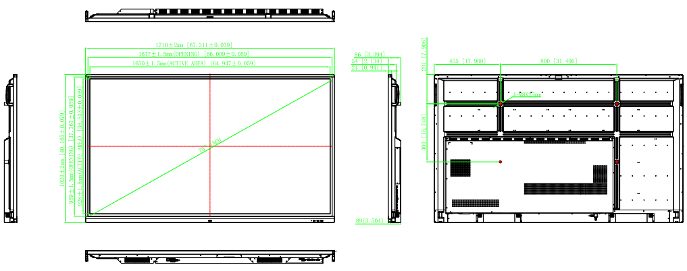

Chapter 5. Packaging Portion

5.1. Packing size
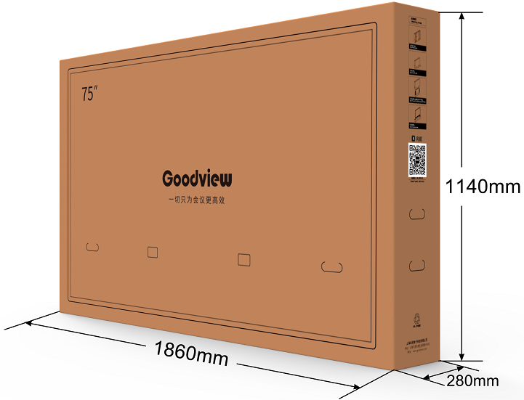

5.2. Packaging Drawings
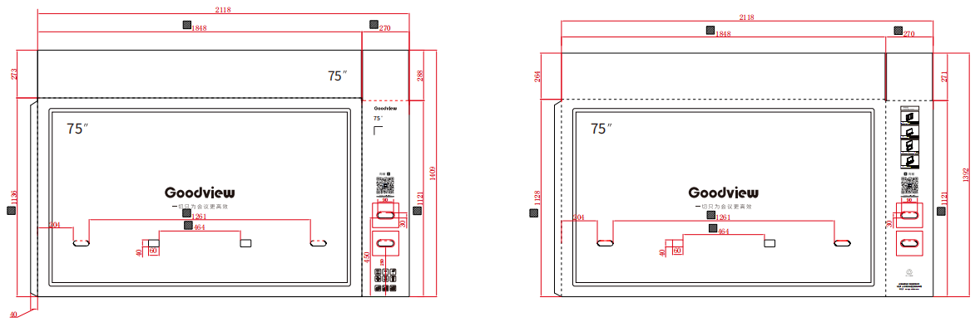

5.3. Labels & Barcode

5.3.1. Nameplate

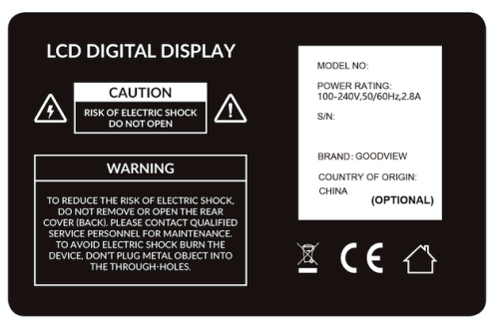

5.3.2. Packing Label
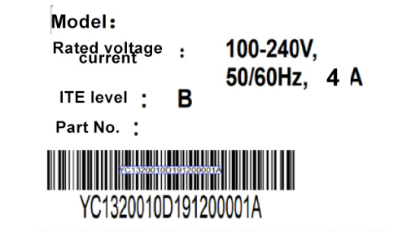

Chapter 6. Environmental Requirement

6.1. Operating Temperature
Item | Symbol | Values |  |  | Unit | Note
 |  | Min | Typ | Max
Operating Temperature | Hop | 0 | - | 40 | ℃
Operating Ambient Humidity | Hop | 10% | - | 90% | RH | Relative humidity (non-condensing).

6.2. Storage Temperature
Item | Symbol | Values |  |  | Unit | Note
 |  | Min | Typ | Max
Storage Temperature | HST | -20 | - | 60 | ℃
Storage Humidity | HST | 10% | - | 90% | RH | relative humidity (non-condensing).

Chapter 7. ID Rendering

7.1. Six Sides Figure
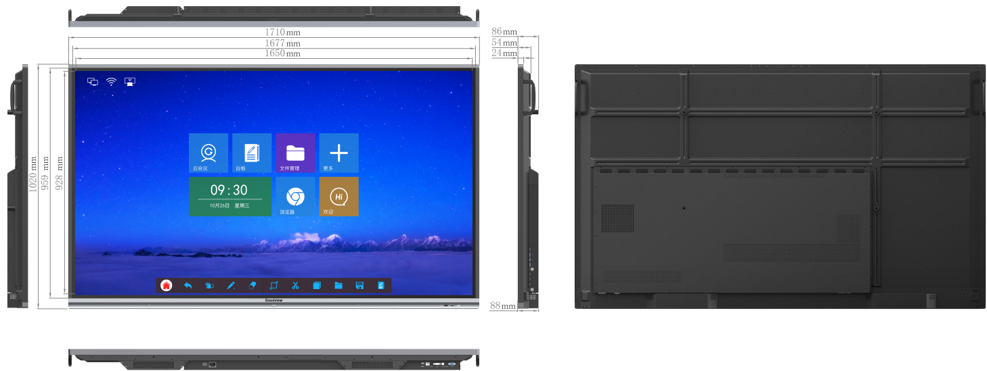

7.2. Front View
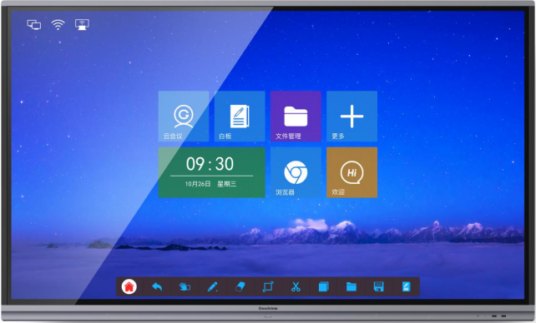

7.3. Reverse View

7.4. Side View
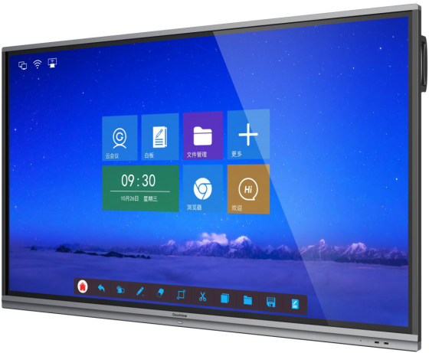

7.5. Interface View
