Shanghai Goodview Electronic Technology Co., Ltd.
Specification
A27HA1(Black Walnut)
Sign and Date by: _________ Sign and Date by: _________

Customer Goodview

Contents
Chapter I. Revision History 2
Chapter II. Summary 3
2.1. Statement 3
2.2. Safety instructions 4
Chapter III. Product Parameter 5
3.1. Main Technical Parameters 5
3.2. LCD Panel Technical Parameters 6
3.3. Specification Overview 7
3.3.1. AC Input Electrical Characteristics 7
3.3.2. Green mode function 7
3.4. External Interface Portion 7
Chapter IV. Mechanical Portion 8
4.1. Outline drawing 8
Chapter V. Packaging Portion 9
5.1. Packing Size 9
5.2. Package Drawing 9
Chapter VI. Nameplate 10
6.1. Nameplate 10
6.2. Labels 11
6.2.1. Nameplate Labels 11
6.2.2. Packaging Labels 11
Chapter VII. Environmental Requirement 12
7.1. Operating Temperature 12
7.2. Storage Temperature 12
Chapter VIII. ID Rendering 13
8.1. Six Sides Figure 13
8.2. Front View 13
8.3. Back View 14
8.4. End View 15
8.5. Interface Rear View 16

Chapter I. Revision History
Parts No. | Version | Revision History | Date | Written by | Auditing | Approval
1490018 | V1.0 | First issue | 2022/2/16 | 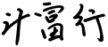  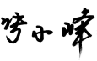 | 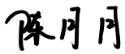 | 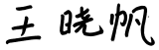

Chapter II. Summary

2.1. Statement
All parts of this product, including accessories and software, all the intellectual property right are owned by Shanghai Goodview Electronic Technology Co., Ltd. (hereinafter refers to "Goodview") or authorizes the relevant subjects xxxx to use. Without the permission of the right subjects, no copying or translation is allowed.
There is no any form of guarantee, position expression or other implication in this manual, if there is any direct or indirect loss of data, loss of profits or termination of business caused by the product information mentioned in this manual, Goodview and its employees are not liable for it. In addition to this, the product specifications and information mentioned in this manual are only for reference and will be updated at any time without further notice. Faults or damages caused by the following factors are not covered by free warranty:
- Damage caused by natural disasters (floods, fires, earthquakes, lightning strikes, typhoons, etc.), force majeure or inadvertent use of man-made operations.
- Self-assemble, repair, or send the product to a maintenance shop not authorized or certified by Goodview for inspection and repair.
- Damages and faults caused by users who may or request a third party to modify, repair, alter specifications and install, add and expand parts that are not sold, authorized or approved by our company without authorization.
- Usage problems and faults caused by improper installation and setting of software by users themselves.
- Problems and malfunctions caused by computer viruses.
- Warranty identification label of our company is torn or unrecognizable.
- Other problems and faults caused by abnormal use.
The product names mentioned in the user's manual are only for identification, and these names may belong to registered trademarks or copyrights of other companies.

Goodview reserves the right to change any or all specifications without notice. The information contained in this document is subject to change without notice.

For the latest upgrade information of product specifications, please call to Shanghai Goodview Electronic Technology Co., Ltd.

2.2. Safety instructions
Safety of Electrical
- In order to avoid serious damage caused by possible electric shock, please remove the power cord of the equipment temporarily from the power socket before moving the equipment
- When you want to add or remove the hardware device in the system, you must connect the data line of the device first and then the power line. If possible, unplug the power cord of the device before installing the hardware device.
- Before you connect or unplug any data lines from the module, make sure that all the power lines have been unplugged beforehand.
- Before using an extension card or an adapter card, we suggest that you seek for professional assistance first. These devices may interfere with the grounding circuit.
- Make sure that the voltage settings of the power supply have been adjusted to the voltage standard values used in the country/region. If you are not sure what the supply voltage value is in your area, please ask the local power company personnel nearby.
- If the power supply is damaged, please do not attempt to repair it by yourself. Please seek the help of professional technical service personnel.
Safety in operation
- Before you install modules and add hardware devices, be sure to read the relevant information provided in this manual in detail.
- Before using the product, make sure that all the data lines and power lines are connected correctly. If you find any defects, please contact Goodview as soon as possible.
- In order to avoid electrical short circuit, make sure that all unused screw, paper clip and other parts are put away, and do not leave them on the module or in the equipment.
- Dust, moisture and drastic temperature changes will affect the life of the motherboard, so please try to avoid placing them in these places.
- Do not place the equipment in a place that is easy to shake.
- If there are any technical problems in the use of this product, please contact the technicians who have been verified or experienced.

Chapter III. Product Parameter

3.1. Main Technical Parameters
NO | Subtype | Name | Parameter | Unit | Note
1 |  | Panel | 27 inches (68.6mm) LED backlight
2 | Product  Parameter | Product size (mm) | 711.1(H)×449.7(V)×33.95(D) | mm
3 |  | Active size (mm) | 597.89mm(H) ×336.31mm(V)） | mm
4 |  | Color | White / Black walnut frame
5 |  | Weight (Gross) | 7.7 | KG
6 |  | Weight (Net) | 5.4 | KG
7 |  | Speaker | Stereo 1.5W 8Ω*2 | Watt
8 |  | Screen hanging mode | Landscape\Portrait
9 |  | OSD Language | Chinese
10 |  | Play mode | Vertical, Horizontal
11 |  | Media transmission | WAN,LAN
12 |  | Watch dog | Supported
13 |  | Schedule On/Off | Supported
14 | Core | CPU | UNISOC UIS8581 /8 Core Cortex A55
16 |  | GPU | Quad core ARMMail-764
17 |  | Memory | 2GB LPDDR4
18 |  | Storage | 32GB eMMC
25 | Installation | VESA standard | 100*100
26 |  | Hanging mode | Hanging bracket
27 | Accessories |  | - Power adaptor ×1  - M4*30 screwsx4  - Double sided Tape x10  - Gradienter ×1  - Installation paper×1
28 | Certification

3.2. LCD Panel Technical Parameters
 |  | Symbol | Parameter |  |  | Unit | Note
 |  |  | Min | Typ | Max
LCD Panel Size |  |  | - | 27 | - | inches | Led backlight
Active Screen Size |  |  | 597.888×336.312 |  |  | mm
Pixel Format |  |  | 1920×1080 |  |  | Pixels
Panel Luminance |  |  | 250 | 300 |  | cd/m2
Production Luminance |  |  | 250 | 300 | 300 | cd/m2
Contrast Ratio |  | CR | 700 | 1000 | -
Color Depth |  |  | 8bit, 16.7 Million colors
Pixel Pitch |  |  | 0.3114x0.3114 |  |  | mm
Color Gamut |  |  |  | 72 |  | %
Response Time |  | G to G BW | - | 14 | 25 | ms
Backlight Life Time |  |  | 30000 | - | - | Hrs
Viewing Angle | Xaxis,right=0° | R | 85 | 89 | -
 | x axis, left=180° | L | 85 | 89 | -
 | y axis, up =90° | U | 85 | 89 | -
 | yaxis, down=270° | D | 85 | 89 | -

3.3. Specification Overview

3.3.1. AC Input Electrical Characteristics

Item | Symbol | Values |  |  | Unit | Note
 |  | Min | Typ | Max
AC Power Input Voltage | AC IN | - | 24 | - | VAC
AC Power Input Current | TBD | / | / | 2 | AAC
Power Consumption | TBD | / | / | 30 | Watt

3.3.2. Green mode function

Item | Symbol | Values |  |  | Unit | Note
 |  | Min | Typ | Max
Stand-by power consumption | TBD | / | / | 0.5 | Watt

3.4. External Interface Portion
NO | Subtype | Name | Number | Parameter
1 | Ac input | Adaptor | ×1 | 2 pin plug, 2 meters

Chapter IV. Mechanical Portion

4.1. Outline drawing
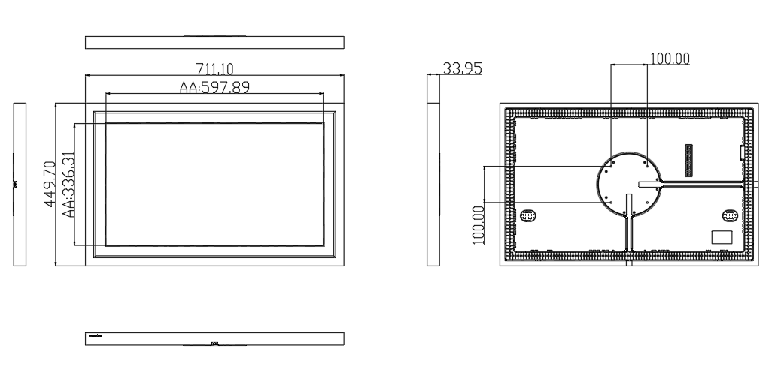

Chapter V. Packaging Portion

5.1. Packing Size
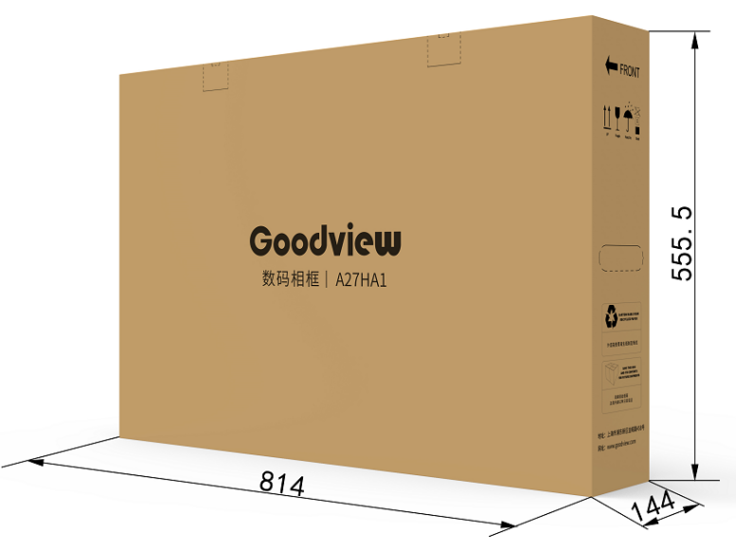

5.2. Package Drawing
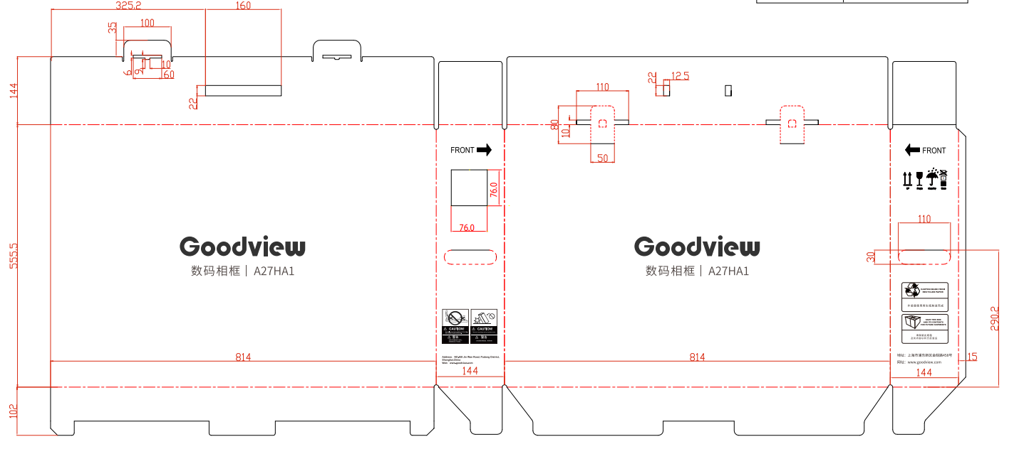

Chapter VI. Nameplate

6.1. Nameplate
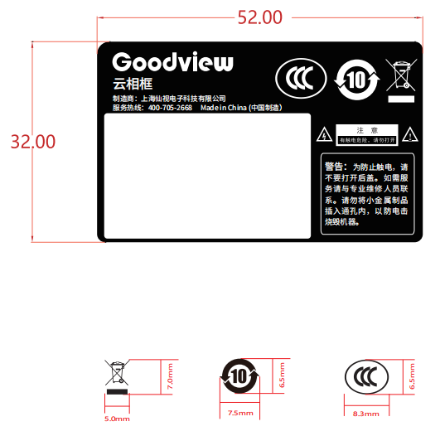

6.2. Labels

6.2.1. Nameplate Labels
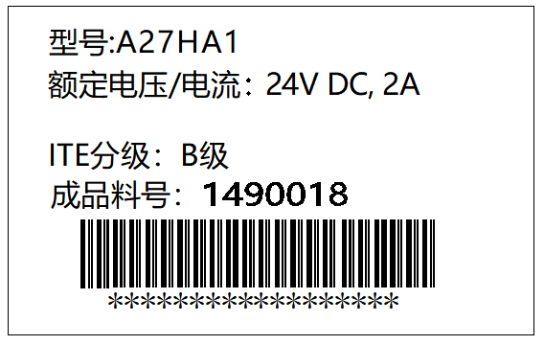

6.2.2. Packaging Labels
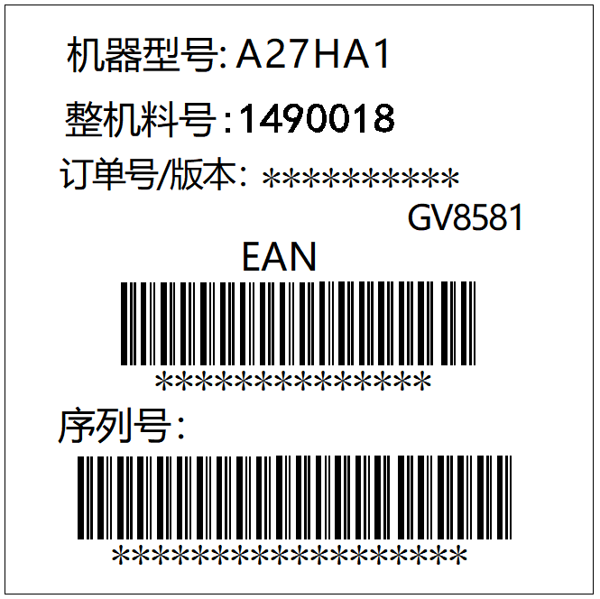

Chapter VII. Environmental Requirement

7.1. Operating Temperature
Item | Symbol | Values |  |  | Unit | Note
 |  | Min | Typ | Max
Operating Temperature | Hop | 0 | - | 40 | ℃
Operating Ambient Humidity | Hop | 10% | - | 80% | RH | Relative humidity (non-condensing).

7.2. Storage Temperature
Item | Symbol | Values |  |  | Unit | Note
 |  | Min | Typ | Max
Storage Temperature | HST | -10 | - | 55 | ℃
Storage Humidity | HST | 10 | - | 80% | RH | relative humidity (non-condensing).

Chapter VIII. ID Rendering

8.1. Six Sides Figure
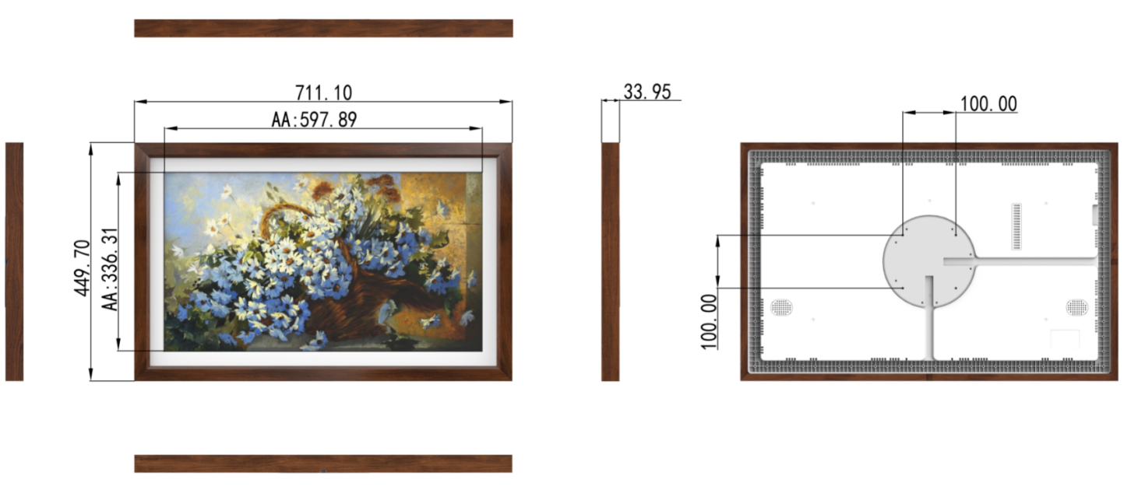

8.2. Front View
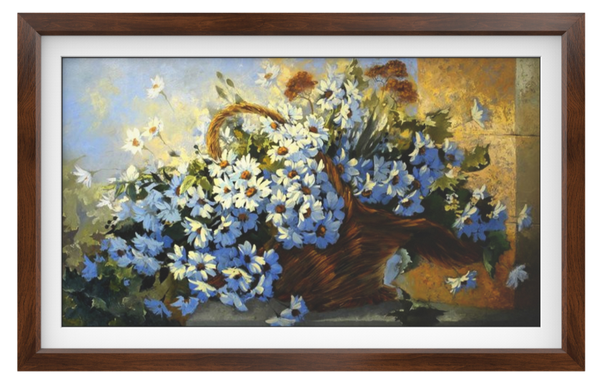

8.3. Back View
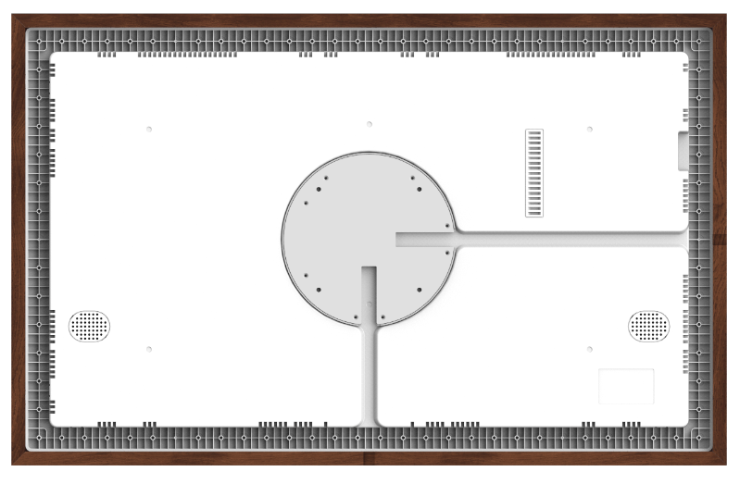

8.4. End View
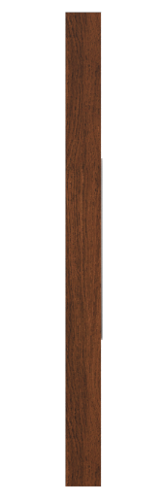

8.5. Interface Rear View
